fMRI Preprocessing implementer and contact information

Zhang Min
Mayo Clinic
chinazm@gmail.com

fMRI Processing Procedure

Step 1. Check whether the images did Slice timing correction step or not.

If yes, go to step 2.

If not, do the slice timing step.

Step 2. Realign(estimated)
Do the realign step:
Batch->SPM->Spatial->Realign(estimated):
Interpolation: Trilinear
Other settings: default
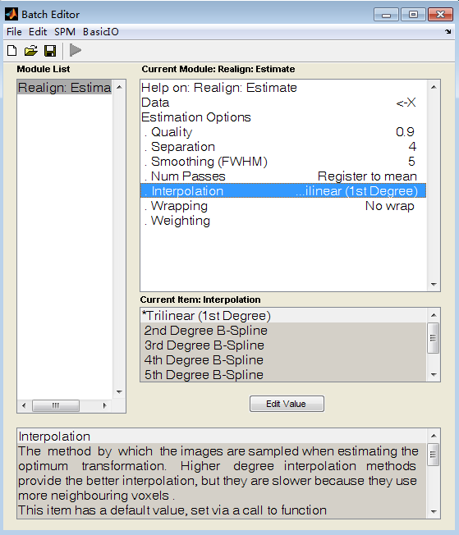
See the result below:
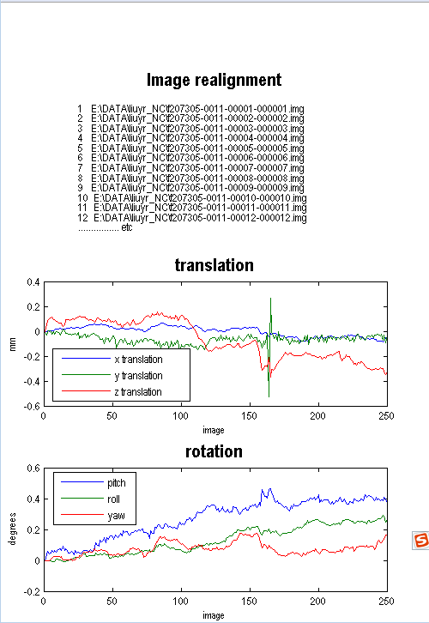

If there is a sharp change in the results, we should go back to adjust the position or size of the images and do the realign again.

Step 3. Realign (Reslice)
Do the realign (Reslice) step:
Batch->SPM->Spatial->Realign(Reslice):
Interpolation: Nearest Neighbor
Other settings: default

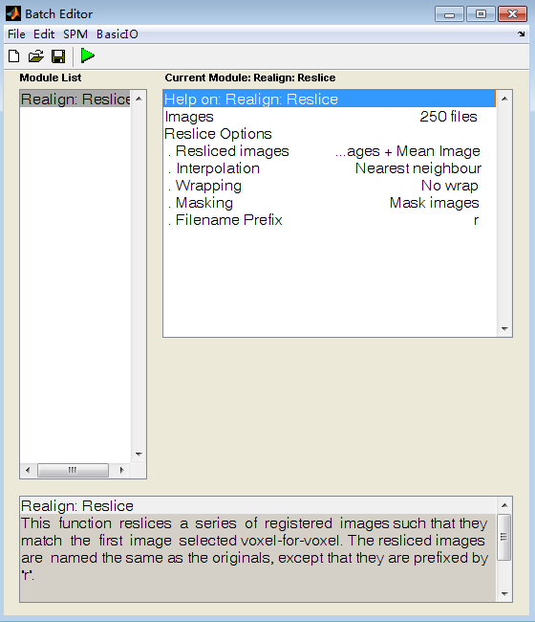

This step will generate r* output files and mean image file

Step 4. Spatial normalized
Do the Normalize (Estimated & Write) step:
Batch->SPM->Spatial->Normalize->(Estimated & Write):
Data:
Source Image: Mean image generated by step 3.
Images to Write: time series fmri images generated by step 3 (r*).
Estimation Option:
Template Image: spm8\templates\EPI.nii
Write Option:
Bounding Box = -90 -126 -74
90 90 106
Voxel Size = 2 2 2
Interpolation: Trilinear

Other settings: default

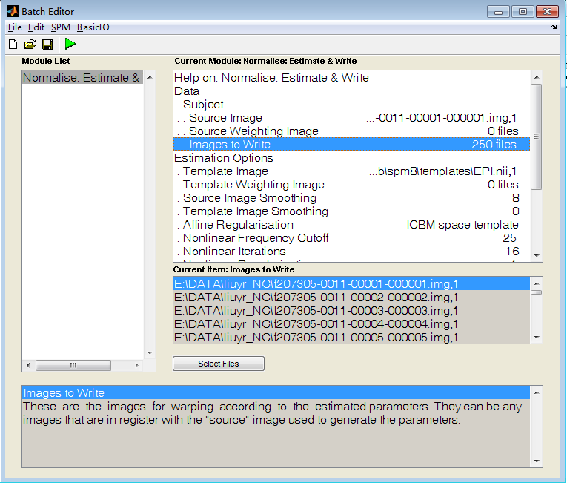

After this step, the w* files generated can be used for future analysis.

Attention:
After each step, it is necessary to visually check some of the source images for quality control.

Step 5 AAL
roifile='C:\Program Files\MATLAB\spm8\toolbox\aal\ROI_MNI_V4.nii';
list=load('C:\Program Files\MATLAB\spm8\toolbox\aal\ROI_MNI_V4_List.mat');
menu1=ls('C:\data\bnu_data\NC\*_NC');

[tmp rgnum]=size(list.ROI);
e=zeros(250,rgnum,16);spm
for u = 1:length(menu1);

file=ls(strcat('C:\data\bnu_data\NC\',menu1(u,:),'\wrf*.img'));

[fnum tmp] = size(file);
img=spm_read_vols(spm_vol(roifile));
for i=1:fnum
disp(u*1000+i);
s=strcat('C:\data\bnu_data\NC\',menu1(u,:),'\',file(i,:));
s=spm_read_vols(spm_vol(s));
for j=1:rgnum
ind=find(img==list.ROI(1,j).ID);
a=zeros(size(img));
a(ind)=1;
mate=a.*s;
mate=mate(ind);
e(i,j,u)=mean(mate);
end
end
end

